BCA Ready Virtual Inspection Solution
Introduction
To assess if the solution is ready for BCA inspections, vendors would need to demonstrate that their solution is able to:
- Provide a Virtual Digital Twin of the site
- Allow user to pin comments within the platform
- Able to attach photo of a sample measurement
- Able to generate an inspection/closure report
For solution that can conduct digital measurement within the platform, they would need to further provide
- Accuracy of the Virtual Inspection Platform system (taking into account both the hardware camera and the software accuracy)
- Feature to assist taking the measurements within the platform.
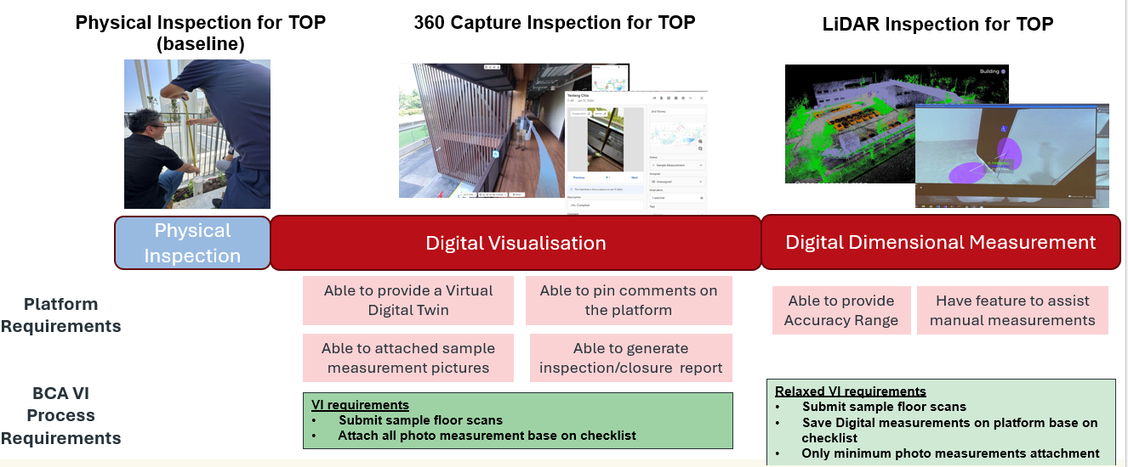
This checklist provides vendors with the essential requirements and procedures for vendors to demonstrate if their virtual inspection solution is aligned for BCA inspections.
Vendor would require conducting the scan at BCA Academy and provide the digital scan for BCA officer to assess if the solution is a BCA Virtual Inspection Ready Solution that
- qualifies under the ‘Digital Visualisation Category’ and/or
- qualifies under the ‘Digital Dimensional Measurement’ Category.

BCA Academy Demonstration Site
The demonstration will follow a predetermined route through BCA Academy to ensure consistent evaluation across all solutions.

Details of solution
Please complete the table below:
Name of the Solution
Company
Contact Person
Contact No.
Contact Email
Type of Virtual Inspection Solution | Digital Visualisation | ☒
Type of Virtual Inspection Solution | - system is on Cloud | ☐
Type of Virtual Inspection Solution | - able to attach comments and photo | ☐
Type of Virtual Inspection Solution | - able to generate an inspection report and a closure report | ☐
Type of Virtual Inspection Solution | - [optional] has BCA clause in the system | ☐
Type of Virtual Inspection Solution | Digital Dimensional Measurement | ☐
Type of Virtual Inspection Solution | - Accuracy of the measurements | Eg. ±5mm
Type of Virtual Inspection Solution | - Make and Model of the Camera/LiDAR Scanner used
Type of Virtual Inspection Solution | - Description of solution (Eg. Tripod base, handheld, robotic)
Link to assess the scan
Any other instruction to assess the scan

Location of Scan
BCA Academy  200 Braddell Road, Singapore 579700  Level 2 | 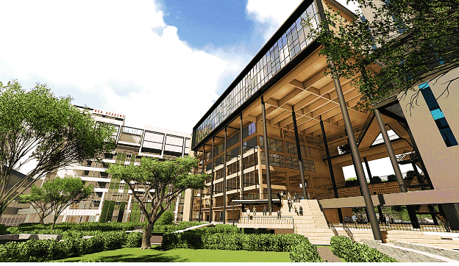

Floor Plan of Scan
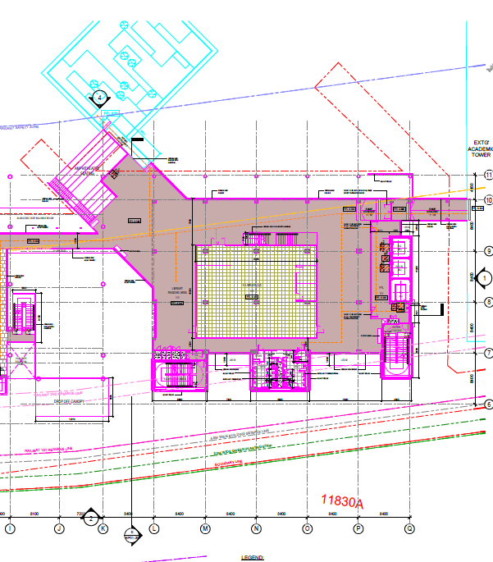

Scanning route:
BCA Academy – Level 2 (Engineered Timber building)
The floor plan below shows the walking route to be captured.
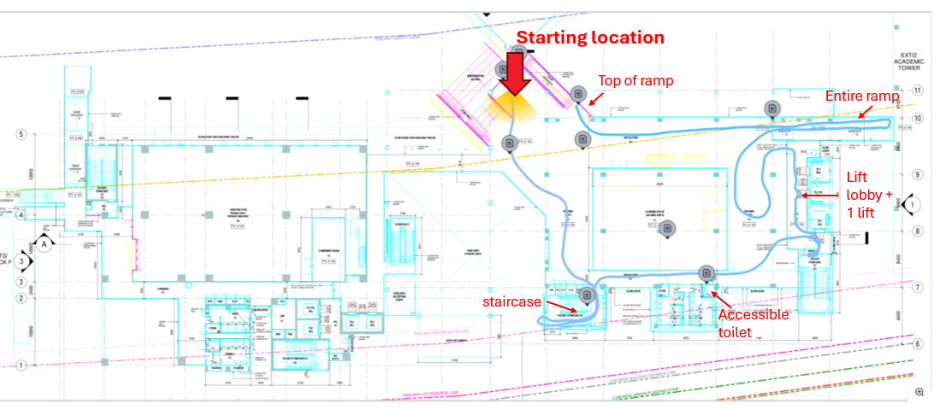
[Note: The key areas to be captured are identified by the red arrows]
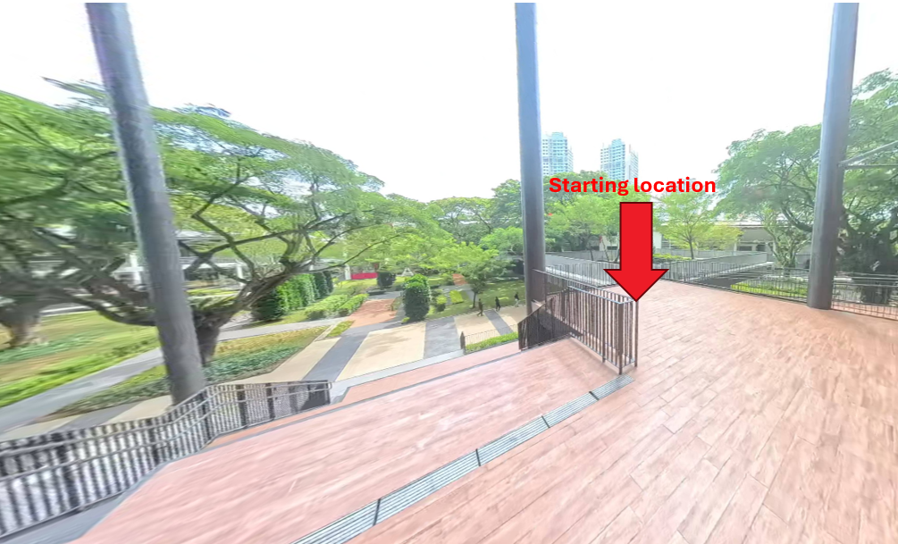

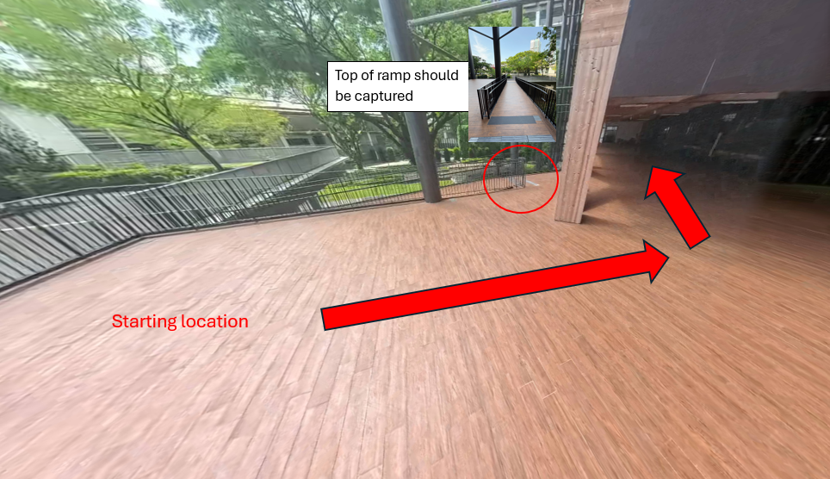

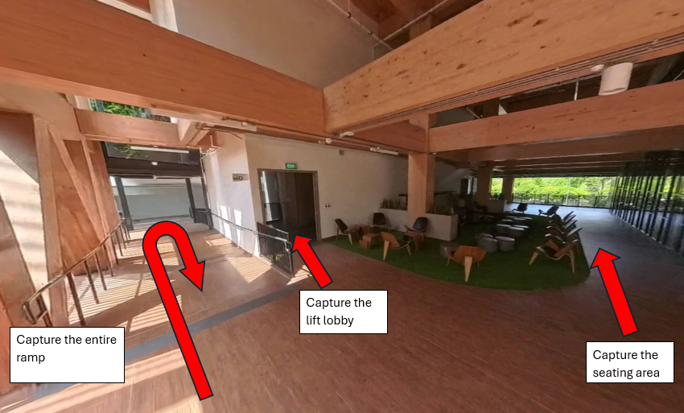
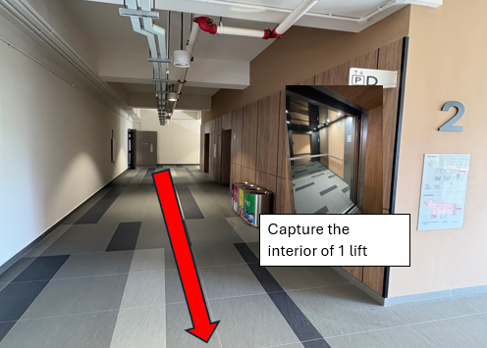

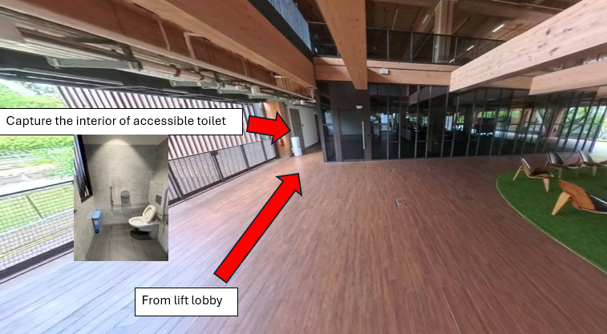
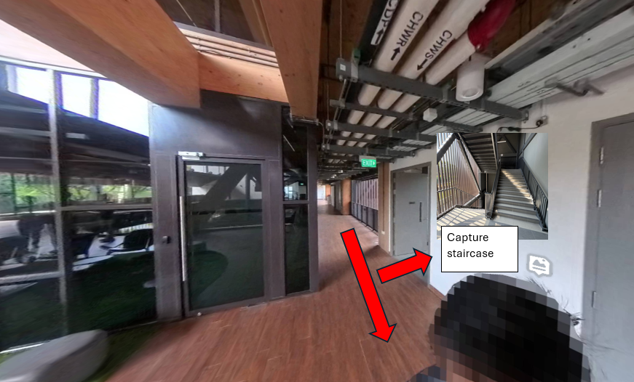

Sample Measurements (Digital Dimensional Measurement solutions only)
For solutions demonstrating their digital measurement capability, sample measurements are to be provided at some key locations. Please measure them digitally and save the measurements in your platform.
Location: Starting Location (external staircase)
Measurement 1:
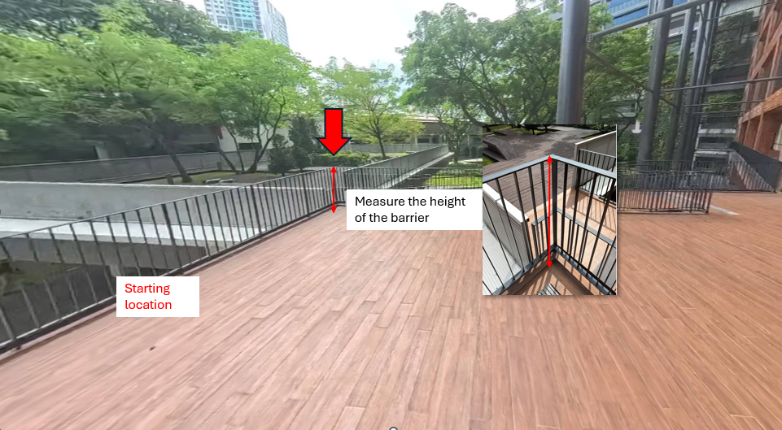

Measurement 2:
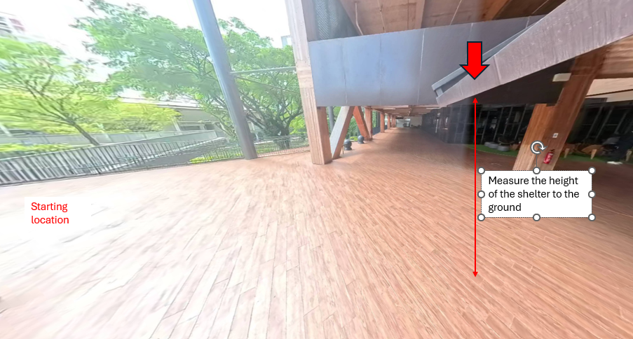
Measurement 3 and 4:
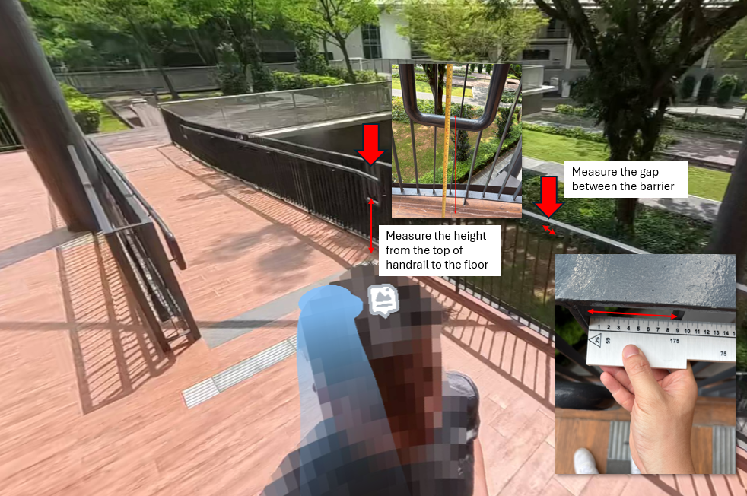
Location: Ramp beside lift lobby
Measurement 5:
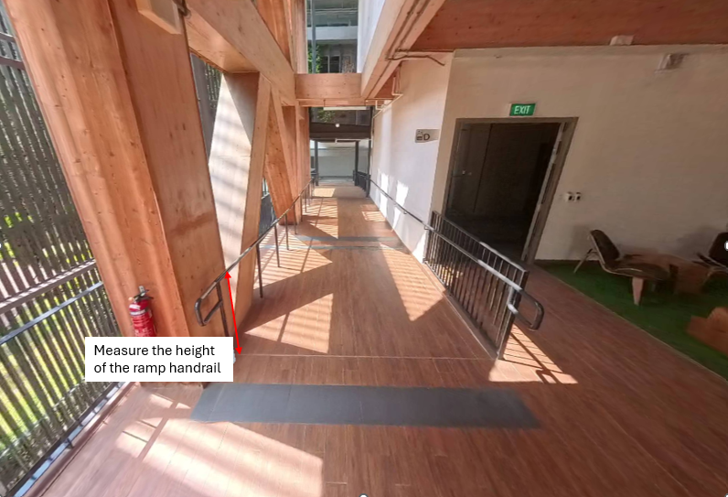
Location: Accessible toilet
Measurement 6:
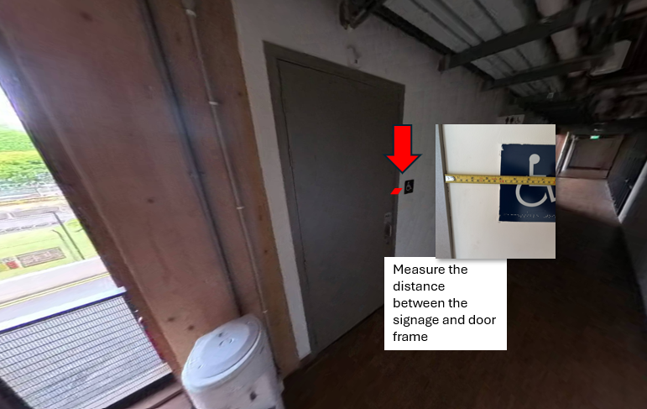
Measurement 7:
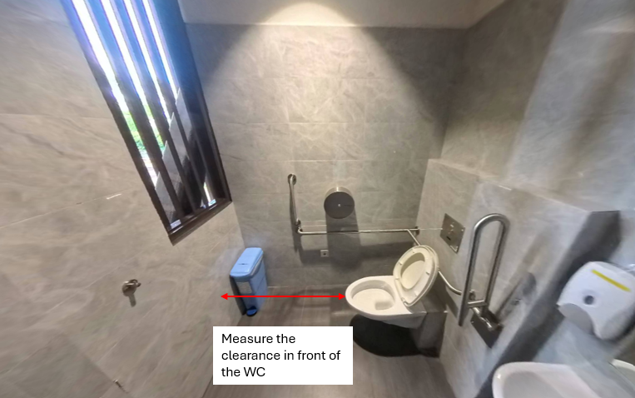

Location: Staircase beside toilet
Measurement 8:
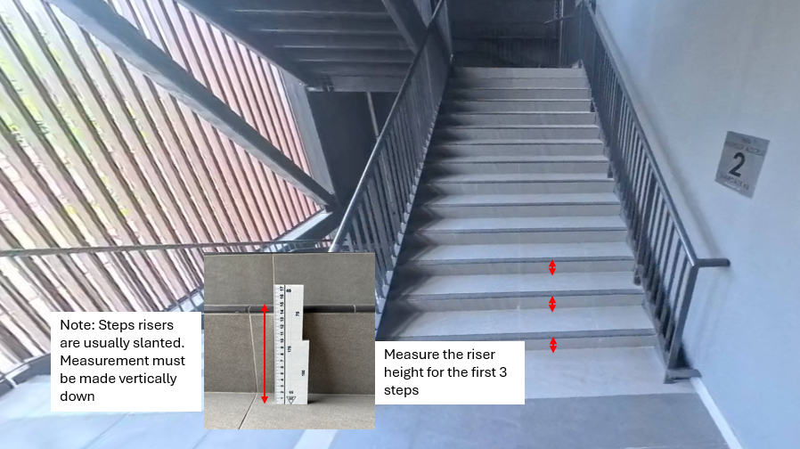

Attachment of Photo 1

